**1. Identify a specific interface, which requires some improvement. You must conduct research into the interface, and then redesign the chosen interface with your knowledge. Outline when, how and why this interface is used.**

Website: <http://www.custompc.ie/>

When: It is used when a customer would like to build their own PC and would like to have all the parts available to them in one site.

How: The customer selects parts and compares them to other parts and compares prices.

Why: It allows a customer quick comparisons between parts of a computer that they may be interested in purchasing.

The website has a changing background and multiple changing pictures making visibility of the website difficult and cramped creating unappealing visuals.

The website has too many words and clickable feature on their homepage providing a cleaner interface with a detailed interactive menu.

**2. What methods are you going to use to gain more knowledge of this type of system – internet research, use of similar systems, interviews, journal articles …..?**

Internet research and use of similar websites such as <https://pcpartpicker.com/>

The website needs to have a friendlier interface where everything is not cramped together and the user knows clearly what they are looking at.

**3. What *process* or *life-cycle* is the most suitable for the redevelopment of your system? Why is this one more suitable than others? How is usability factored into the process?**

The Star Life Cycle is the most suitable for this system because it enables you to evaluate and make changes constantly depending on user feedback and changes occur in the requirements.

**4. Discuss the different types of requirements that are currently in this system. Through what methods have you identified these? Draw a use-case diagram for your system.**

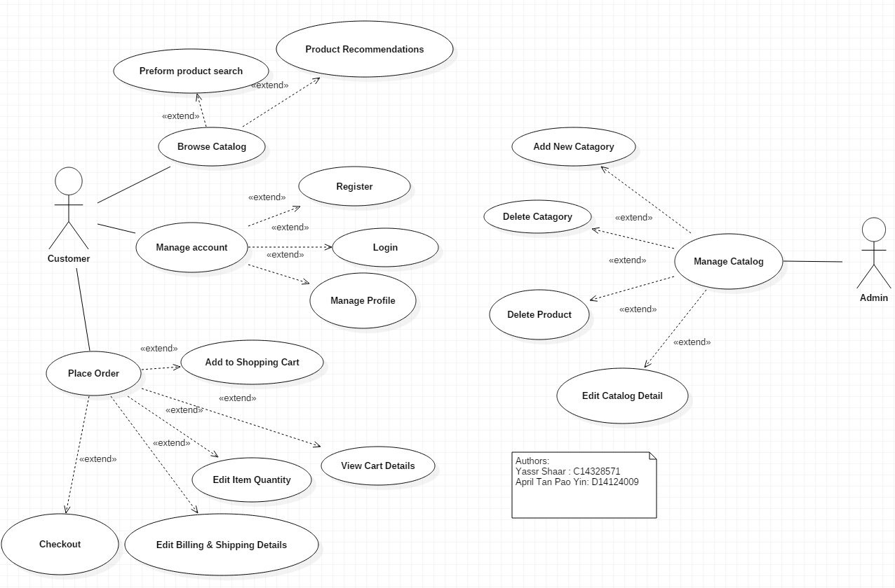

Task Analysis

The customer browses a catalog of parts that will help them to build a PC.

They would choose different parts and add up the prices.

The customer/user can perform product searches and place orders.

The User chooses the pieces then is given the information about the compatibility of the parts together.

The user needs to be able to manage their account to place orders and purchases off the website and interact with it.

The admin must be able to update the catalog on the website to keep the products up to date with the rapid change in technology.

User Analysis

Expert and frequent users of PC’s would be the most interested and capable in using this website.

The user must not be visually impaired because the website is hard to read.

This website is catered to young adults that are familiar with computer parts.

The culture of using this website is like a complicated jig-saw of pc parts so that you choose each part and finally see the price of a full custom pc.

Environment Analysis

Sharing options are available onto social media.

Physical environment is not relevant because the customer would be able to use the website through the internet regardless of device.

The site is helpful towards customers as they have all their social media accounts linked on the homepage, and also on a navigation bar at the top of the page. They also have a contact us tab that is obvious

**5. What user group(s) is your choice of interface focused on?**